CREATE JAVA APPLICATION

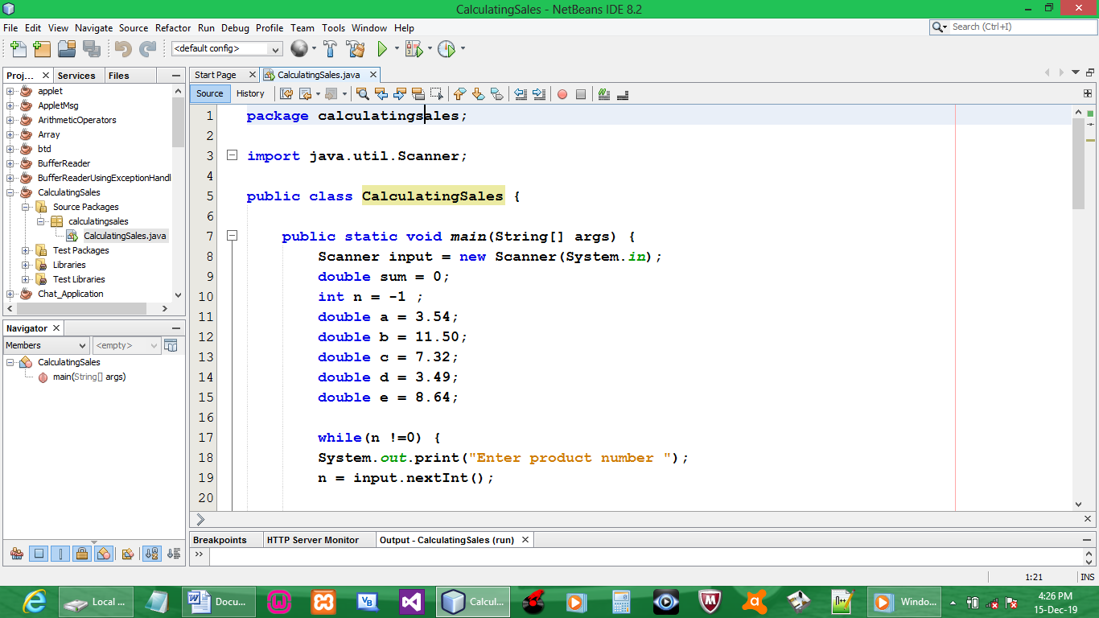

CODE:

package calculatingsales;

import java.util.Scanner;

public class CalculatingSales {

public static void main(String[] args) {
Scanner input = new Scanner(System.in);
double sum = 0;
int n = -1 ;
double a = 3.54;
double b = 11.50;
double c = 7.32;
double d = 3.49;
double e = 8.64;

while(n !=0) {
System.out.print("Enter product number ");
n = input.nextInt();

if (n==6)
break;

System.out.print("Enter the number of quantity sold ");
int q = input.nextInt();

if(n == 1){
System.out.print("The retail price is R" + a + "\n\n");
}

if(n == 2){
System.out.print("The retail price is R" + b + "\n\n");
}
if(n == 3){
System.out.print("The retail price is R" + c + "\n\n");
}
if(n == 4){
System.out.print("The retail price is R" + d + "\n\n");
}
if(n == 5){
System.out.print("The retail price is R" + e + "\n\n");
}

switch (n) {
case 1:
a = 3.54 * q;
sum += 3.54 * q;
case 2:
b = 11.50 * q;
sum += 11.50 * q;
break;
case 3:
c = 7.32 * q;
sum += 7.32 * q;
break;
case 4:
d = 3.49 * q;
sum += 3.49 * q;
break;
case 5:
e = 8.64 * q;
sum += 8.64 * q;
break;
default:
sum += 0;
break;
}
}
System.out.println("The total retail for product One is R" + a + "\n");
System.out.println("The total retail for product Two is R" + b + "\n");
System.out.println("The total retail for product Three is R" + c + "\n");
System.out.println("The total retail for product Four is R" + d + "\n");
System.out.println("The total retail for product Five is R" + e + "\n");
System.out.println("Total cost is R" + sum + "\n");
System.out.println("\n");
}
}

OUTPUT:

